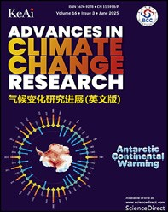Available online at [www.sciencedirect.com](http://www.sciencedirect.com/science/journal/16749278)  ScienceDirect



[Advances in Climate Change Research 16 (2025) 460e472](https://doi.org/10.1016/j.accre.2025.04.003)

[www.keaipublishing.com/en/journals/accr/](http://www.keaipublishing.com/en/journals/accr/)

Radiative effects of black carbon in the Arctic due to

recent extreme summer fires

Xin-Tong CHENa, Shi-Chang KANGb,c,*, Dong-Hang SHAOa,**, Yu-Ling HUa, Jun-Hua YANGa, Mian XUa

a State Key Laboratory of Cryospheric Science and Frozen Soil Engineering,

Northwest Institute of Eco-Environment and Resources, Chinese Academy of Sciences, Lanzhou 730000, China b Institute of Mountain Hazards and Environment, Chinese Academy of Sciences, Chengdu 610213, China c University of Chinese Academy of Sciences, Beijing 100049, China

Received 11 November 2024; revised 31 March 2025; accepted 2 April 2025

Available online 10 April 2025

Abstract

Black carbon (BC) affects the Arctic climate via aerosol‒radiation‒cloud interaction and snow/ice albedo feedback. Fires have become a substantial source of the Arctic BC in recent years, while the radiative effects of BC in the Arctic due to the recent extreme fires remain unclear. In this study, the atmospheric and snow radiative forcing of BC in the Arctic due to the extreme fires in summer 2019 were investigated based on numerical simulations, and the effects on meteorological variables and snow albedo were explored. Biomass burning BC in summer 2019 caused negative radiative forcing at the bottom of the atmosphere in Greenland and the central Arctic Ocean, and it caused positive radiative forcing in Europe, central Siberia, and northern Canada, with values that can reach 9 W/m2 and 18 W/m2, respectively. The radiative forcing was spatially heterogeneous, which was mainly induced by the dominant role of semi-direct and indirect radiative effects of BC related to cloud changes. The air temperature in the higher troposphere increased in the central Arctic Ocean and Greenland, and the near-surface air temperature increased in Europe, central Siberia, and northern Canada. The responses of wind field and relative humidity were mainly linked with the air temperature changes, and the cyclone activity anomaly can be observed in the central Arctic. Biomass burning BC caused positive snow radiative forcing in Greenland of 0.4e1.4 W/m2, and the maximum snow albedo reduction was about 0.005. Overall, this study highlights the importance of BC from fires on the Arctic climate.

Keywords: Black carbon; Biomass burning; Radiative effects; Snow albedo; Arctic

|  |  |
| --- | --- |
| 1. Introduction  Global warming exacerbates fire conditions, leading to the increase of frequency and intensity of fires (Baker, 2022; Galizia et al., 2023; McCarty et al., 2021; Oris et al., 2014). | Under future warming, fire-prone regions will continue to increase and fire season will continue to lengthen globally (Lund et al., 2023; Pimont et al., 2023; Senande-Rivera et al., 2022). Notably, the Arctic warming rate was approximately four times larger than the global average rate since 1980 (Sweeney et al., 2023). In the context of rapid warming, fires increased |
| * Corresponding author. Institute of Mountain Hazards and Environment, Chinese Academy of Sciences, Chengdu 610213, China.  ** Corresponding author.  E-mail addresses: shichang.kang@lzb.ac.cn (KANG S.-C.), shaodonghang@ lzb.ac.cn (SHAO D.-H.).  Peer review under responsibility of National Climate Centre (China  Meteorological Administration) | largely and unprecedented fires were observed in the circumArctic region in recent years, attracting widespread attention (Descals et al., 2022; Witze, 2020).  Fires in the circum-Arctic region in recent 20 years were concentrated in Siberia and northern North America and mainly originated from the burning of boreal forest (Chen |

<https://doi.org/10.1016/j.accre.2025.04.003>

1674-9278/© 2025 The Authors. Publishing services by Elsevier B.V. on behalf of KeAi Communications Co. Ltd. This is an open access article under the CC BY-NC-ND license (<http://creativecommons.org/licenses/by-nc-nd/4.0/>).

et al., 2023a). During 2001e2020, the average burned area in the Arctic was 31.2 103 km2 (Xing and Wang, 2023).

Particularly, the burned area in the Siberian Arctic increased by a factor of 2.6 from 2001e2010 to 2011e2021 (Kharuk et al., 2022). The years of 2019 and 2020 were marked as the two extreme fire years (McCarty et al., 2020; Talucci et al., 2022). The average burned area in the Arctic in 2019 was 51.9 103 km2, which was the maximum value during 2001e2020 and was approximately 1.7 times larger than the multi-year average (Xing and Wang, 2023). Additionally, the Arctic warming accelerated the northward expansion of boreal climate zone and agriculture climate zone, and therefore the potential fires are expected to increase and expand northward (Liu and Yang, 2022; Parfenova et al., 2019; Zhang et al., 2024).

Fires bring a substantial impact on ecosystem and climate, and also bring an impact on air quality and human health. Climate regulates the occurrence of fires by regulating warmer and drier fire conditions, and fires emit numerous aerosols that can in turn affect climate (Dong et al., 2021; Sarangi et al., 2023; Tian et al., 2022). Climate-fire interaction and feedback have become a hot research issue, and are especially important in the Arctic due to the sensitivity of this region to climate warming. BC aerosol has a strong light-absorbing property, and fire emissions are the large and increasing sources of the Arctic BC (AMAP, 2021). Previous studies revealed that the contributions of summer fires to the BC at the surface and high altitudes in the Arctic were 56%e85% and 40%e72%, respectively (Zhu et al., 2020), and summer fires could contribute over 60% of the deposited BC in the Arctic (Matsui et al., 2022). In the atmosphere, BC absorbs solar radiation resulting in direct radiative effect (Jacobson, 2001), and it further affects atmospheric static stability, moisture flux, cloud cover, and cloud formation, so called as semi-direct radiative effect (Allen and Sherwood, 2010). BC serving as cloud condensation nuclei affects cloud cover, cloud lifetime, and precipitation, is known as indirect radiative effect (Lohmann and Hoose, 2009). Additionally, BC reduces surface albedo of snow/ice and accelerates melting when it deposits on snow/ice (Chen et al., 2024; Doherty et al., 2013; Jiao et al., 2014; Kang et al., 2020). BC can affect climate via these complex aerosol‒radiation‒cloud and snow/ice albedo feedbacks, leading to radiative, meteorological, and snow responses.

The understanding and quantification of BC effects on the Arctic climate has generated considerable research interests. Using reanalysis data and model simulation, a previous study revealed that biomass burning aerosols (dominated by smoke particles) induced the average direct radiative forcing of 13.1 ± 2.7 W/m2 at the Arctic surface in July 2015, and the values can reach 85 W/m2 and 41 W/m2 over Alaska and Svalbard (Markowicz et al., 2017). Based on model simulation, Kostrykin et al. (2021) suggested that BC from the Siberian fires in July and August 2019 induced the maximum direct radiative forcing of 4e5 W/m2 in the Arctic atmosphere, and induced the maximum snow radiative forcing of 0.5e1 W/ m2. Using model simulation, Evangeliou et al. (2019) indicated that BC and brown carbon from fires in western Greenland in July and August 2017 led to the largest albedo decrease of nearly 0.007, and the maximum instantaneous radiative forcing at the surface was 0.63e0.77 W/m2. The important effects of BC from fires on the Arctic have been confirmed in previous studies. When more fires outbreak in the future, a large amount of BC transporting and depositing may cause substantial effects on the Arctic climate system. However, the studies about the radiative effects of BC in the Arctic considering the recent extreme fires are still limited, and the associated meteorological and snow responses are not well understood.

This study focused on the radiative effects of BC in the Arctic contributed by the fires occurred in the circum-Arctic region in summer 2019. By conducting the Weather Research and Forecasting model coupled with Chemistry (WRF-Chem) and the Community Earth System Model Version 2 (CESM2) simulations, the atmospheric and snow radiative forcing of BC were investigated, and the responses of meteorological variables and snow albedo were explored. The results can provide insights into the important effects of fire emissions on the Arctic climate change and snow/ice melting.

1. Data and methods
   1. The simulation of biomass burning BC effects in theatmosphere

|  |  |  |  |  |  |  |  |  |  |  |  |  |  |  |  |  |  |  |  |  |  |  |  |  |  |  |  |  |
| --- | --- | --- | --- | --- | --- | --- | --- | --- | --- | --- | --- | --- | --- | --- | --- | --- | --- | --- | --- | --- | --- | --- | --- | --- | --- | --- | --- | --- |
| Table 1  WRF-Chem simulation configurations.   |  |  | | --- | --- | | Atmospheric process | Option | | Microphysics | Morrison two-moment (Morrison et al., 2009) | | Longwave radiation | RRTMG (Iacono et al., 2008) | | Shortwave radiation | RRTMG (Iacono et al., 2008) | | Cumulus | Grell 3D (Grell and Devenyi, 2002) | | Planetary boundary layer | YSU (Hong et al., 2006) | | Land surface | Noah (Chen and Dudhia, 2001) | | Gas-phase chemistry | CBM-Z (Zaveri and Peters, 1999) | | Aerosol | MOSAIC (Zaveri et al., 2008) | | Meteorological initial and boundary condition | NCEP FNL | | Chemical initial and boundary condition | CAM-chem output (Buchholz et al., 2019) | | Anthropogenic emission inventory | EDGAR-HTAP (Janssens-Maenhout et al., 2015) | | Biogenic emission inventory | MEGAN (Guenther et al., 2006) | | Biomass burning emission inventory | FINN v1.5 (Wiedinmyer et al., 2011) | |

The WRF-Chem model was applied to investigate the atmospheric radiative forcing of biomass burning BC and its effects on meteorological variables. The WRF-Chem model is fully coupled and can simulate meteorology and chemistry processes simultaneously (Skamarock et al., 2008). It is widely applied to investigate aerosols effects on climate from different emission sources, such as anthropogenic activity and fire emissions (Dong et al., 2024; Marelle et al., 2015; Rai et al., 2022; Yang et al., 2022b). The horizontal resolution of the WRF-Chem domain was 55 km including 216 187 grids, and the vertical layer had 30 levels from the surface to the top of 50 hPa. The WRF-Chem domain included the high latitudes and some areas of the middle latitudes of the Northern Hemisphere covering the primary biomass burning emission areas. The simulation was conducted from 13 June to 31 August 2019, and the first five days were used for model spin-up. Other detailed configurations of the WRF-Chem simulation were summarized in Table 1. The microphysics and longwave and shortwave radiation schemes selected have been widely used, and the capability of the WRF-Chem model on radiation simulation has been validated in previous studies (Porter et al., 2011; Sotiropoulou et al., 2019; Thomas et al., 2017; Yahya et al., 2017). BC from fires in summer 2019 and its radiative effects were simulated using the emission sensitivity approach with emission perturbations (Sobhani et al., 2018; Wang et al., 2014; Yang et al., 2019). Two parallel sensitive experiments with and without biomass burning BC emission were conducted (CON and SEN experiments). In CON experiment, biomass burning BC emission was turned on and this experiment was defined as a control experiment. In SEN experiment, biomass burning BC emission was turned off and other settings were the same as in CON experiment. Therefore, the atmospheric radiative forcing induced by biomass burning BC and the effects on meteorological variables were quantified through the differences between CON and SEN experiments results. Biomass burning BC emission was obtained from the Fire INventory from NCAR (FINN v1.5). FINN v1.5 utilizes satellite observations of active fires and provides a high temporal (daily) and spatial (1 km) resolution inventory, which estimates near real-time biomass burning emissions and is widely used in regional and global chemical transport models (Leaitch et al., 2020; Liu et al., 2020; Wiedinmyer et al., 2011; Yang et al., 2022a). For biomass burning emission, the WRF-Chem model contains an online plume calculation and is capable of computing the plume rise based on the simulated meteorology (Grell et al., 2011). Biomass burning emission including the plume rise settings were turned on in the WRF-Chem simulations. In addition, the NOAA’s National Centers for Environmental Information Global Summary of the Day data and the fifth generation European Centre for Medium-Range Weather Forecasts (ECMWF) atmospheric reanalysis of the global climate (ERA5) data were used to evaluate the model performance on meteorological variables (Hersbach et al., 2023). The level-3 Moderate Resolution Imaging Spectroradiometer (MODIS) atmosphere monthly data were used to evaluate the model performance on aerosol optical depth (Platnick et al., 2015).

* 1. The simulation of biomass burning BC effects insnow

The snow radiative forcing induced by biomass burning BC and the effects on snow albedo changes were simulated using the CESM2 model. The CESM2 is a fully coupled global climate model (Danabasoglu et al., 2020), and it integrates the Community Land Model Version 5 (CLM5), which uses the fully coupled Snow, Ice, and Aerosol Radiative (SNICAR) scheme to simulate snow radiative transfer. The new SNICAR scheme meticulously considers the optical properties of nonspherical BC particles and BC mixed with snow (Flanner et al., 2021). The accuracy of the SNICAR in simulating snow albedo has been thoroughly validated and demonstrated in previous studies (Flanner et al., 2021; Flanner and Zender, 2006; Whicker et al., 2022). The Global Soil Wetness Project Phase 3 (GSWP3) atmospheric forcing data were used to drive the offline CESM2 model. The radiative effects resulting from the deposition of all atmospheric biomass burning BC into snow were simulated in this study. The atmospheric biomass burning BC concentrations were derived from the preceding WRF-Chem model results. The WRF-Chem can provide higher resolution simulations of meteorological and chemical processes. The CESM2 can simulate snow process changes on land surfaces in more detail, which is important for accurately modelling the BC-induced snow albedo changes. The advantages of the WRF-Chem for higher resolution simulation of BC concentration and the CESM2 for snow process simulation were combined to better estimate the radiative effects of BC. The spatial resolution of the continuous offline simulations was 0.9 1.25, and we performed 400 spin-up years of the model in 2018 before simulating the 2019 results. The radiative forcing calculation scheme was based on the methodology proposed by Painter et al. (2013), which was developed specifically for the radiative forcing of light-absorbing impurities. The emission sensitivity approach was also applied in the CESM2 simulations to quantify the effects of biomass burning BC in snow. The snow spectral albedos with and without biomass burning BC contamination were simulated separately using the CESM2 model (CON1 and SEN1 experiments), and then the radiative forcing was calculated based on the spectral albedos. Similarly, the snow radiative forcing induced by biomass burning BC and the effects on snow albedo changes were quantified through the differences between CON1 and SEN1 experiments results.

1. Results and discussion
   1. Biomass burning BC concentrations

The performance of the WRF-Chem model against observations and reanalysis data in 2019 has been validated in our previous works using the same domain as well as the same physics and chemistry options as described in section 2.1 (Chen et al., 2023b). Compared with in-situ observations, the WRF-Chem well reproduced the temporal variations of monthly average BC concentrations (correlation coefficients (R) ¼ 0.320.90, mean biases (MB) are from 0.01 to

0.01 mg/m3) and aerosol optical depth (AOD, R are 0.73 and 0.86, MB are 0.04 and 0.0003) in 2019 (Chen et al., 2023b). To evaluate the performance of the WRF-Chem model further, the average near-surface BC concentrations in summer 2019 from the WRF-Chem simulation and CAMchem output, as well as AOD from the WRF-Chem simulation and MODIS data, were compared in Fig. A1. The WRFChem model also captured the spatial distributions of the high near-surface BC concentrations and AOD values well (Fig. A1). Moreover, the simulated and in-situ observed daily averages of meteorological variables during summer 2019 were compared in Fig. A2. The spatial distributions of meteorological variables at different atmosphere heights from the WRF-Chem simulation and ERA5 reanalysis data were compared in Figs. A3A4. As shown in Fig. A2, the WRFChem model generally reproduced the temporal variations of the near-surface air temperature (R ¼ 0.65, MB ¼ 0.97 C), sea level pressure (R ¼ 0.996, MB ¼0.59 hPa), and the near-surface wind speed (R ¼ 0.79, MB ¼1.10 m/s) during summer 2019. The spatial distribution characteristics of the simulated air temperature and wind field at 850 hPa and 500 hPa showed good agreements with the reanalysis data, but the model slightly underestimated the relative humidity at 500 hPa in the central Arctic region (Figs. A3A4).

|  |
| --- |
| Fig. 1. Spatial distributions of biomass burning BC (BC-BB) concentrations at different atmosphere heights in summer 2019. |

The average concentrations of biomass burning BC at different atmosphere heights (near-surface, 850, 500, and 300 hPa) in summer 2019 simulated by the WRF-Chem were displayed in Fig. 1. The near-surface biomass burning BC concentrations were particularly high in Siberia and Alaska in summer 2019, and this was consistent with the locations of satellite observations of fires (Chen et al., 2023a). Near the high-emission area, biomass burning BC was mainly concentrated in the near-surface layer and lower troposphere (850 hPa). In summer, the Arctic front retreated northward, and therefore biomass burning emissions from the south of the Arctic front were transported by following isentropic surfaces upward into the Arctic middle and upper troposphere (AMAP, 2015; Bozem et al., 2019; Chen et al., 2020). In the middle troposphere (500 hPa), biomass burning BC can be transported to the central Arctic region. In the higher troposphere (300 hPa), biomass burning BC concentrations decreased remarkably over the whole domain. Those characteristics were closely related to the seasonal changes of the polar dome, which affected the transport pathways of emissions from

middle and high latitudes to the Arctic. Nevertheless, the underestimation of relative humidity at 500 hPa in the central Arctic reflected the uncertainties in wet deposition process in the WRF-Chem model, which could potentially lead to the overestimation of BC in the middle troposphere. The removal mechanism in the WRF-Chem model didn’t include the effects of aerosols in ice nucleation, and it also led to the underestimation of BC deposition in the Arctic region (Thomas et al., 2017). Moreover, the uncertainties in emission inventory and fire plume rise process could also affect the simulation results. Previous studies indicated that the reproduce of fire plume rise process is still a challenge in atmospheric chemistry transport models, including the WRF-Chem, and it revealed the need to further improve the plume rise parameterization as well as the meteorological field and emission inputs (Han et al., 2022; Jin et al., 2024; Ye et al., 2021, 2022).

* 1. Atmospheric radiative forcing induced by biomassburning BC

Fig. 2 shows the average net radiative forcing induced by biomass burning BC in summer 2019. In Fig. 2a, the net radiative forcing of BC at the bottom of the atmosphere in Greenland and the central Arctic Ocean was mainly negative and can reach 9 W/m2 in some areas, indicating the nearsurface cooling induced by biomass burning BC. The noticeable negative values of up to 18 W/m2 can be observed in northeastern China, the northern Atlantic Ocean, and the northeastern Pacific Ocean. In contrast, biomass burning BC induced noticeable positive radiative forcing of up to 18 W/m2 in Europe, central Siberia, and northern Canada. The net radiative forcing of BC at the top of the atmosphere had similar spatial distributions but presented larger positive values compared with it at the bottom of the atmosphere (Fig. 2b). The net radiative forcing in the atmosphere was calculated as the difference between the net radiative forcing at the top and at the bottom of the atmosphere. The net radiative forcing values in the atmosphere induced by biomass burning BC were mainly positive over the whole domain (Fig. 2c). Overall, the radiation perturbations induced by biomass burning BC were spatially heterogeneous, since those involved the combined influence of direct, semi-direct, and indirect radiative effects of BC (Filioglou et al., 2019; Forkel et al., 2012; Koike et al., 2021; Stofferahn and Boybeyi, 2017).

The BC-induced longwave and shortwave radiative forcing at the bottom and at the top of the atmosphere were displayed in Fig. 3. The downward shortwave radiative forcing and net radiative forcing at the bottom of the atmosphere presented similar spatial distributions, and the downward shortwave radiative forcing had larger positive and negative values (Figs. 2a and 3c). While at the top of the atmosphere, the upward shortwave radiative forcing had opposite values compared with the downward shortwave radiative forcing at the bottom of the atmosphere (Fig. 3a and c). The BC-induced shortwave radiative forcing at the bottom and at the top of the atmosphere can be positive or negative, suggesting the influence of aerosol‒radiation‒cloud interaction. In order to remove the influence of clouds, the downward shortwave radiative forcing at the bottom of the atmosphere induced by biomass burning BC in clear-sky condition was presented in Fig. 4. In clear-sky condition, biomass burning BC can reduce the shortwave radiation reaching the surface directly by absorbing solar radiation. The larger negative values were observed in Siberia, which were consistent with the distribution of highconcentration biomass burning BC. Moreover, clear-sky solar radiation can also be modulated by the changes in water vapor in response to biomass burning BC perturbations. Previous studies revealed that aerosols and water vapor exerted the most effects on clear-sky solar radiation (Obregon et al., 2018; Yu et al., 2022; Zhang and Ma, 2020). However, the clear-sky shortwave radiative forcing was relatively weak, indicating that the semi-direct and indirect radiative effects related to cloud changes were primary contributors to the radiation changes. Fig. 5 presents the BC-induced cloud

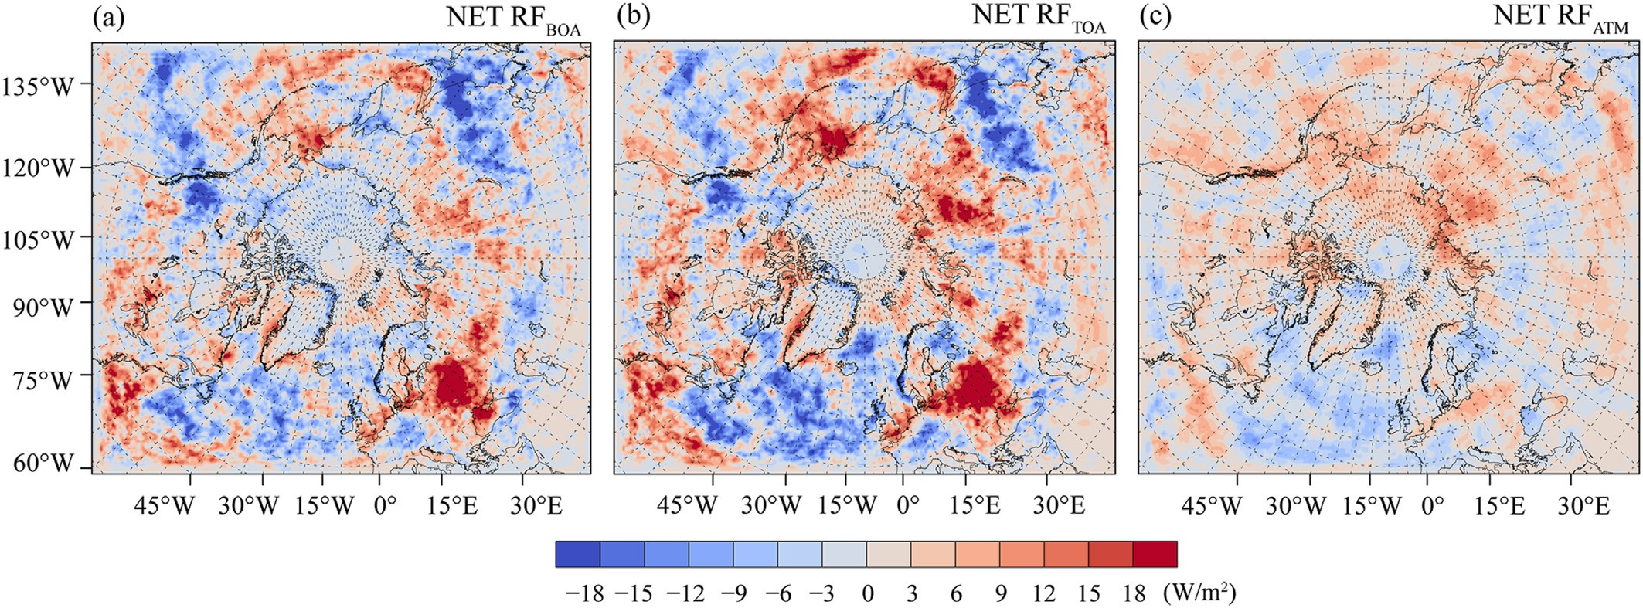

Fig. 2. Spatial distributions of net radiative forcing induced by biomass burning BC in summer 2019, (a) at the bottom of the atmosphere, (b) at the top of the atmosphere, and (c) in the atmosphere.

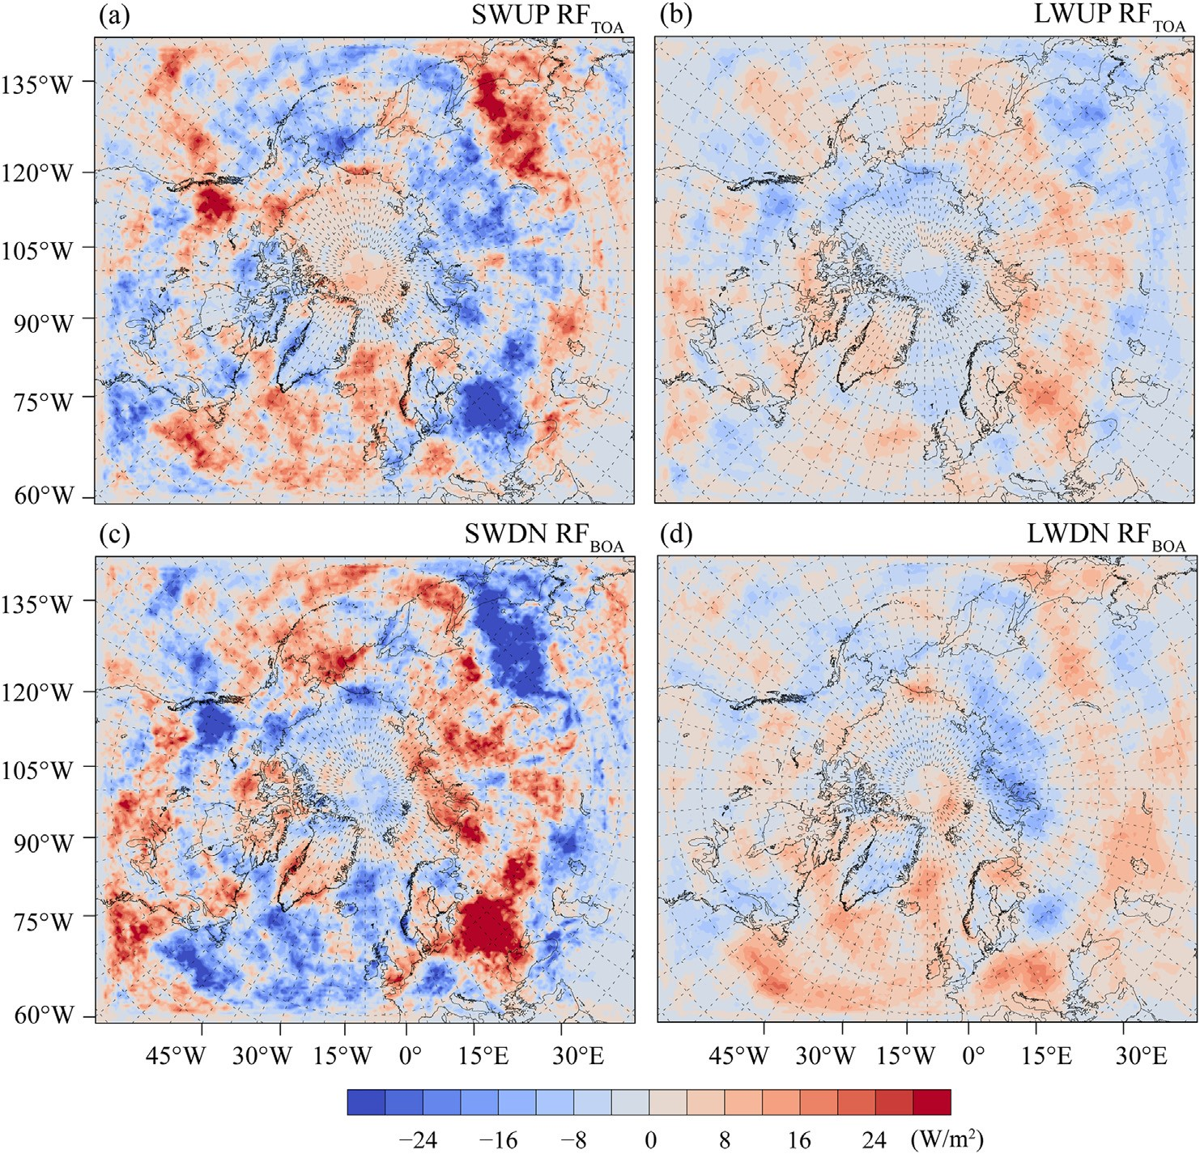

Fig. 3. Spatial distributions of shortwave and longwave radiative forcing induced by biomass burning BC in summer 2019, (a) upward shortwave radiative forcing at the top of the atmosphere, (b) upward longwave radiative forcing at the top of the atmosphere, (c) downward shortwave radiative forcing at the bottom of the atmosphere, and (d) downward longwave radiative forcing at the bottom of the atmosphere.

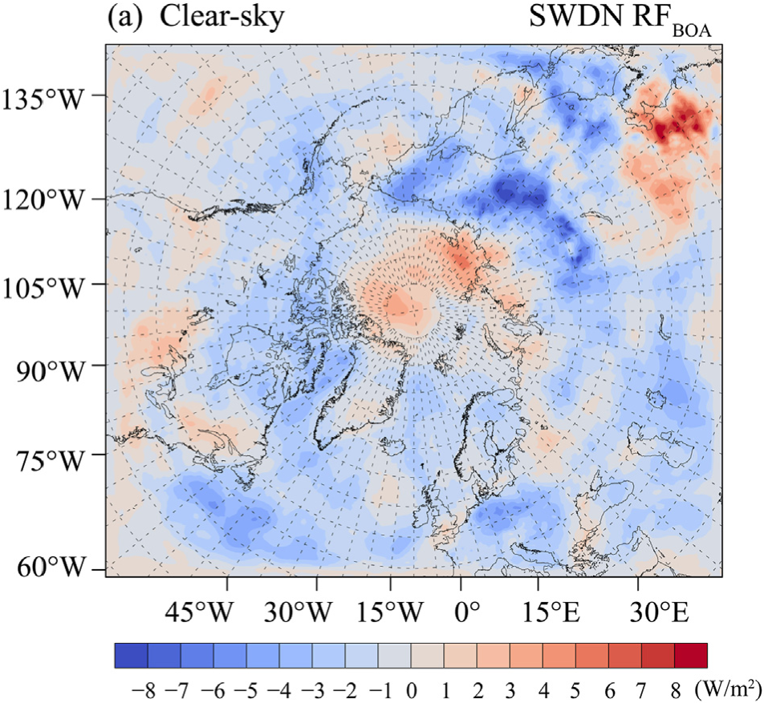

Fig. 4. Spatial distributions of clear-sky downward shortwave radiative forcing at the bottom of the atmosphere induced by biomass burning BC in summer 2019.

|  |
| --- |
| Fig. 5. Spatial distributions of cloud fraction (CF) changes at 850 hPa and 500 hPa induced by biomass burning BC in summer 2019. |

fraction changes in the lower and middle troposphere (850 hPa and 500 hPa), since biomass burning BC was mainly concentrated below the middle troposphere. BC reduced the cloud fraction in the lower and middle troposphere in Europe, Siberia, northern Canada, and the northern Pacific Ocean, indicating that the semi-direct radiative effect of BC could cause the cloud evaporation by heating the atmosphere (Huang et al., 2019; McFarquhar et al., 2011). Hence, it led to the shortwave warming at the near surface, and it reduced the downward longwave radiation and favored the outgoing longwave radiation in those areas (Fig. 3). Also, the semidirect radiative effect of BC could enhance the cloud cover when BC is located above the cloud (Allen et al., 2019; Flanner, 2013; Li et al., 2013). In Fig. 5, the cloud fraction increased in northeastern China, the northeastern Pacific Ocean, the northern Atlantic Ocean, and the central Arctic Ocean in the lower troposphere (Fig. 5), resulting in positive and negative perturbations to the downward longwave and shortwave radiation at the bottom of the atmosphere, respectively (Fig. 3). Additionally, BC can alter cloud albedo and increase cloud cover and lifetime by serving as cloud condensation nuclei (Cherian et al., 2017; Liu et al., 2020; Zhuang et al., 2010). However, the increased cloud fraction caused by the semi-direct and indirect radiative effects of BC could not be distinguished in this study. Most previous studies mainly focused on the direct radiative effect of BC, whereas this study analyzed the combined effects of direct, semi-direct, and indirect radiative forcing of biomass burning BC. Overall, the results showed that the semi-direct and indirect radiative effects of BC dominated over the direct radiative effect on the radiation changes, and BC induced the larger perturbations to the shortwave radiation both at the bottom and at the top of the atmosphere.

3.3. Meteorological variables changes induced by biomass burning BC

Fig. 6 shows the average changes of the near-surface air temperature (2 m air temperature), relative humidity (2 m relative humidity), and wind field (10 m wind field) induced by biomass burning BC. Fig. 7 shows the average changes of air temperature, relative humidity, and wind field in the middle and higher troposphere (500 hPa and 200 hPa) induced by biomass burning BC. The effects of biomass burning BC can be observed from the lower to the higher troposphere due to aerosol‒radiation‒cloud interaction, and a previous study suggested that the climate sensitivity to light-absorbing aerosols can rapidly increase with altitude (Zhang et al., 2017). As displayed in Fig. 6a, BC induced the near-surface air temperature decreasing in Greenland, the central Arctic Ocean, and the adjacent continental areas in Alaska and Russia. The nearsurface air temperature also decreased in northeastern China and the northeastern Pacific Ocean. Those were generally consistent with the negative radiative forcing at the bottom of the atmosphere in the spatial distribution (Figs. 2, 3 and 6). BC induced the near-surface air temperature increasing obviously in Europe, central Siberia, and northern Canada. In the middle troposphere (500 hPa), the air temperature changes were similar with those in the near-surface layer (Fig. 7a). While in the higher troposphere (200 hPa), the air temperature increased in Greenland and the central Arctic Ocean, which have almost opposite characteristics with those in the near-surface layer (Fig. 7b). The above results revealed that biomass burning BC induced the near-surface warming in Europe, central Siberia,

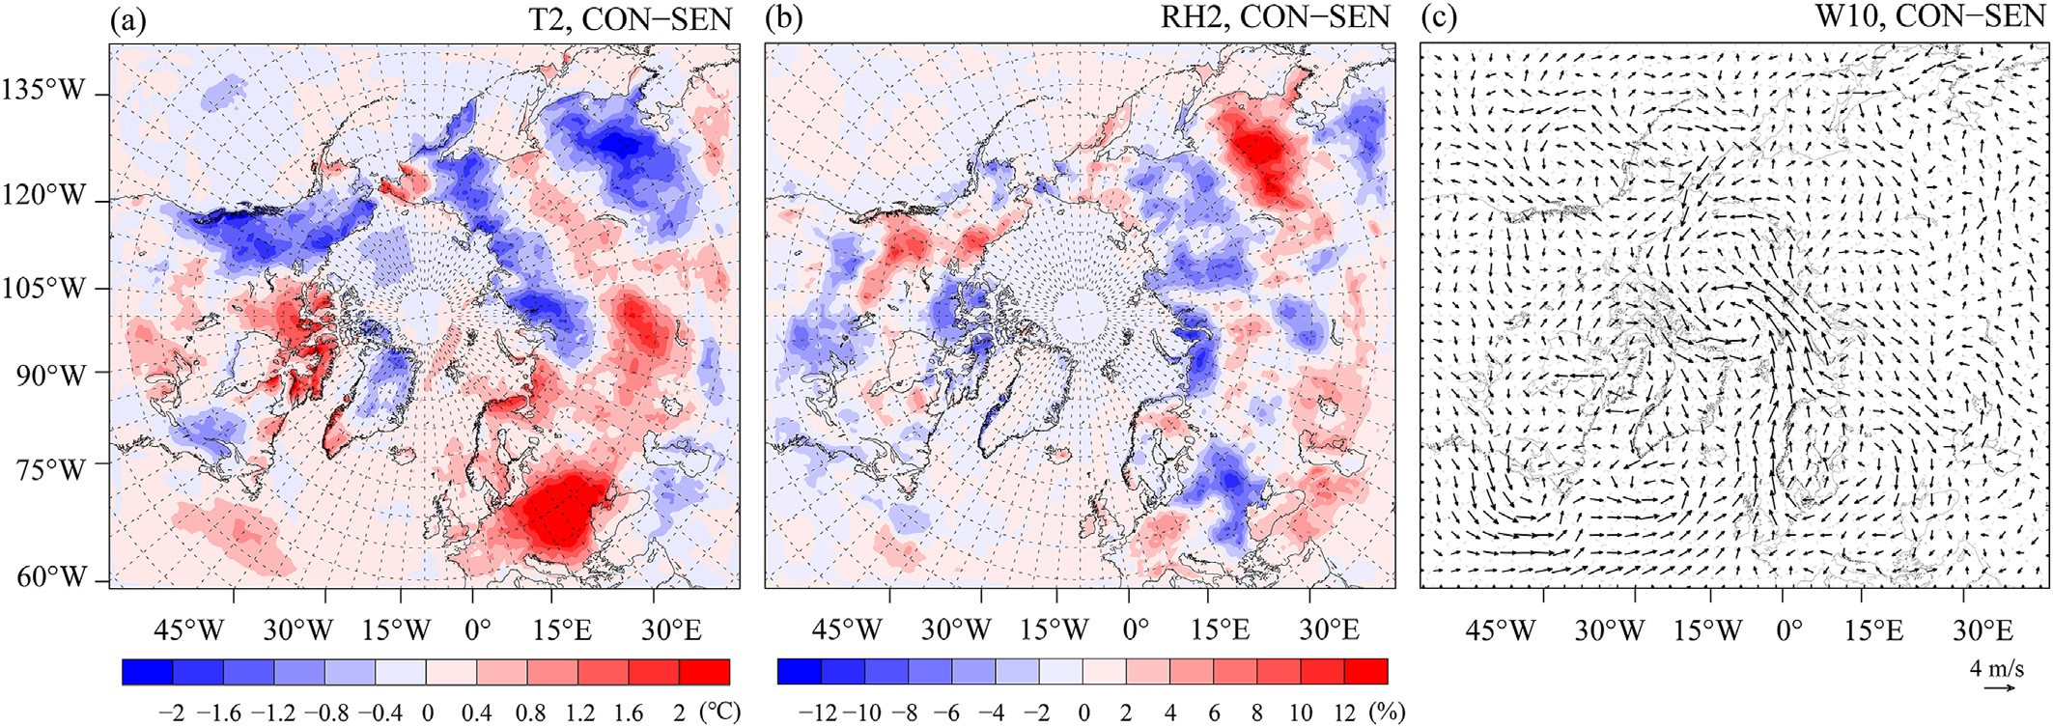

Fig. 6. Spatial distributions of 2 m air temperature (T2), 2 m relative humidity (RH2), and 10 m wind field (W10) changes induced by biomass burning BC in summer 2019.

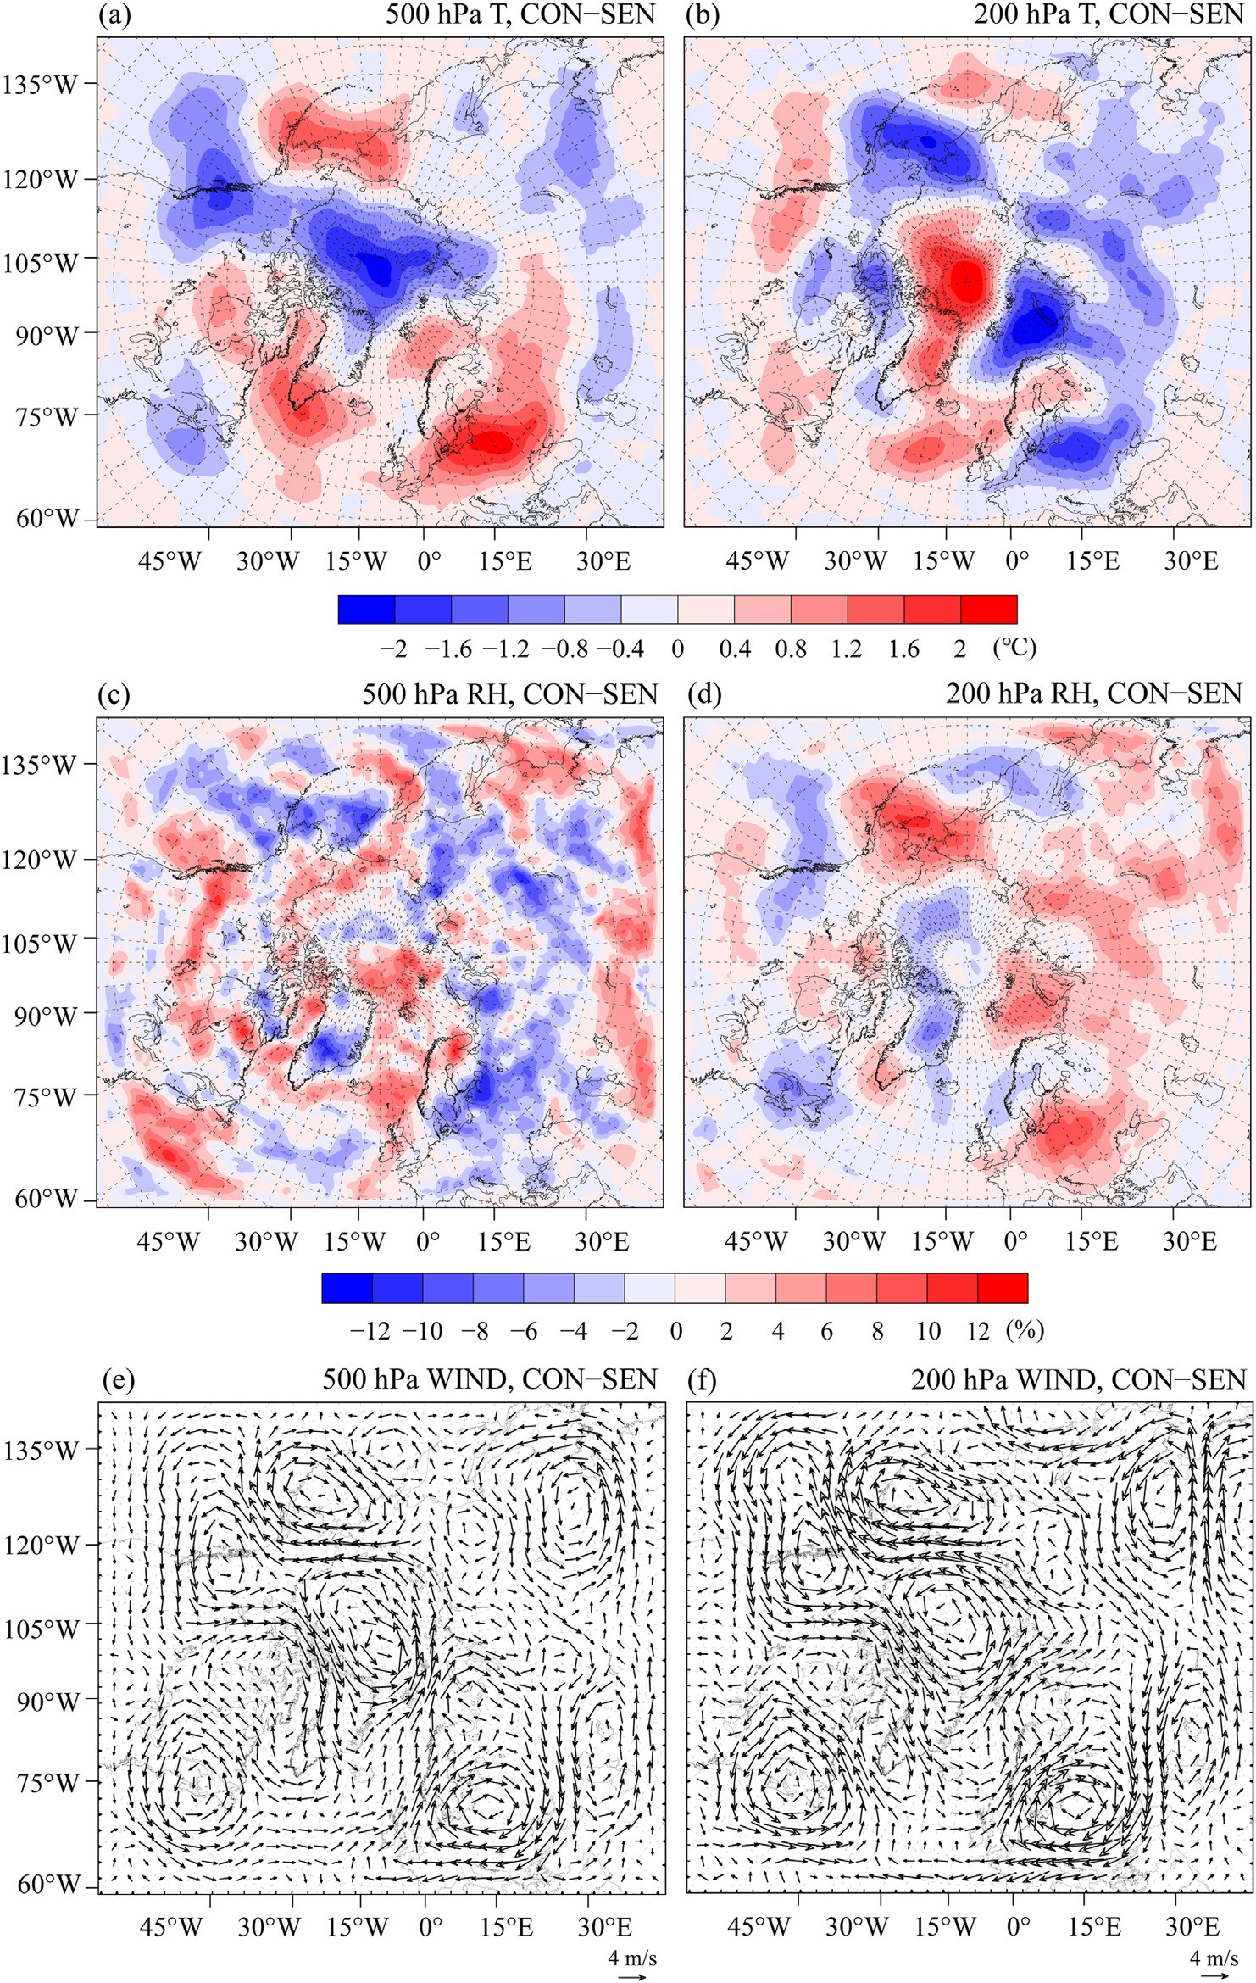

Fig. 7. Spatial distributions of air temperature (T), relative humidity (RH), and wind field (WIND) changes at 500 hPa and 200 hPa induced by biomass burning BC

in summer 2019.

and northern Canada, and it induced the warming in the higher troposphere in the central Arctic Ocean and Greenland, with the air temperature increases that can over 2 C. The changes were spatially heterogeneous, which were mainly owing to the semi-direct and indirect radiative effects of BC related to cloud changes. An increase in air temperature can directly result in a decrease in relative humidity, and vice versa. This characteristic can be observed in the relative humidity changes in most continental areas (Figs. 6 and 7). However, in the Arctic Ocean, the near-surface relative humidity reduced accompanied by the near-surface cooling, and it was likely attributed to the weakened evaporation caused by the cooling in oceanic areas (Fig. 6b). The air temperature perturbations also affected local wind. As shown in Fig. 6c, the cyclone anomaly can be observed in the central Arctic leading to the intensified southwesterly winds in the surrounding areas. The local cyclone anomaly and associated southwesterly winds could promote the convergence of surrounding air towards the central Arctic region. However, the wind fields with and without biomass burning BC emission (CON and SEN experiments) still presented similar patterns overall (Fig. A5), indicating that the BC-induced local air temperature changes led to perturbations in local wind but didn’t cause substantial changes in wind field.

3.4. Snow radiative forcing and albedo changes induced by biomass burning BC

The average snow radiative forcing and albedo changes induced by biomass burning BC in summer 2019 were presented in Fig. 8. The results showed that biomass burning BC induced the positive snow radiative forcing in the Arctic (Fig. 8a). It can induce the warming effect in snow and surface air accelerating snowmelt (Dou and Xiao, 2016; Pu et al., 2021; Qian et al., 2014; Ren et al., 2020). Those positive radiative forcing values were mainly distributed in the Canadian Arctic Archipelago, Greenland, and some areas of northern Russia. Greenland is most affected by fires, with the larger radiative forcing values of 0.4e1.4 W/m2, which was possibly correlated with the high-albedo surface and relatively stronger feedbacks. The positive radiative forcing values in the Canadian Arctic Archipelago and northern Russia were mainly in the range of 0.01e0.6 W/m2. A previous study revealed that biomass burning BC induced the monthly-average snow radiative forcing in the Arctic in summer during 2009e2015 over 0.4 W/m2 (Matsui et al., 2022). Moreover, biomass burning BC induced the average snow radiative forcing in the Arctic in August 2019 of 0.05e1 W/m2 (Kostrykin et al., 2021). The above findings were close to the results of this study in order of magnitude. As shown in Fig. 8b, it can be observed that the decreases of albedo were mainly distributed in Greenland with the average values mainly in the range from 0.003 to 0.0005, and the maximum value was about 0.005. Overall, the snow radiative forcing and albedo changes in the Arctic induced by biomass burning BC in summer 2019 were relatively small, since less biomass burning BC aerosol can be transported into the central Arctic at present. However, when consider the BC enrichment in snow/ice during snow/ice melting (Kang et al., 2020; Zhong et al., 2021), the important role of biomass burning BC should not be ignored in the future. Because the model does not explicitly consider the enrichment of BC within snow and ice layers, this uncertainty limits our understanding of how BC accumulation and re-exposure impact albedo. Additionally, the deposition of BC from various sources also exerted positive feedbacks on sea ice and the Greenland ice sheet (Cho et al., 2019; Dou et al., 2017; Goelles and BØGgild, 2017; Tedesco et al., 2016). However, the albedo feedbacks of sea ice and the Greenland ice sheet induced by biomass burning BC were not analyzed in this study, which could be considerably significant in the Arctic region. Therefore, if more and larger fires outbreak in the circum-Arctic region under future warming, BC from biomass burning is expected to cause substantial snow/ice albedo changes and snow/ice melting.

4. Conclusions

|  |
| --- |
| Fig. 8. Spatial distributions of snow radiative forcing and albedo changes induced by biomass burning BC in summer 2019. |

Using the WRF-Chem and CESM2 simulations, the atmospheric and snow radiative forcing of biomass burning BC in the Arctic in summer 2019 were quantified, and its effects on meteorological variables and snow albedo were explored in this study. Under the combined influence of direct, semidirect, and indirect radiative effects of BC, the atmospheric radiative forcing was not directly related to BC concentration in the spatial distribution. At the bottom of the atmosphere, biomass burning BC induced negative net radiative forcing in Greenland and the central Arctic Ocean, and it induced positive radiative forcing in Europe, central Siberia, and northern Canada, with values that can reach 9 W/m2 and 18 W/m2, respectively. The spatial distribution of the BC-induced net radiative forcing at the top of the atmosphere was similar with it at the bottom of the atmosphere, and the BC-induced net radiative forcing in the atmosphere was mainly positive over the whole domain. The semi-direct and indirect radiative effects related to cloud changes dominated over the direct radiative effect on the radiation changes. Biomass burning BC induced the near-surface air temperature decreasing in Greenland and the central Arctic Ocean and increasing in Europe, central Siberia, and northern Canada. On the contrary, the air temperature increased in the higher troposphere in Greenland and the central Arctic Ocean. The relative humidity changes were almost opposite to the air temperature changes, and BC induced the cyclone anomaly in the central Arctic associated with the intensified southwesterly winds in the surrounding areas. In snow, biomass burning BC induced positive radiative forcing in Greenland of 0.4e1.4 W/m2. Correspondingly, the reduction of snow albedo can be observed in Greenland even though the values were relatively small.

This study highlights the important effects of BC from fires on the Arctic climate change and snow/ice melting. As climate warming is expected to further increase fires and BC emission, those effects are likely to intensify in the future. However, some model limitations are worth noting and these contribute to the uncertainties in the radiative effects estimates in this study. To reduce these uncertainties, further improvement of BC simulation is necessary, particularly in the model representation of fire plume rise and aerosol deposition processes. Additionally, the aerosol‒radiation‒cloud interaction should be quantified separately in future works, and the albedo feedbacks of sea ice and the Greenland ice sheet considering the enrichment of BC should be included, as these are also important for better understanding the radiative effects of BC.

Declaration of competing interest

The authors declare no conflict of interest.

CRediT authorship contribution statement

Xin-Tong Chen: Writing e review & editing, Writing e original draft, Visualization, Methodology, Formal analysis, Data curation, Conceptualization. Shi-Chang Kang: Writing e review & editing, Supervision, Funding acquisition, Conceptualization. Dong-Hang Shao: Writing e review & editing, Methodology, Formal analysis, Conceptualization. Yu-Ling Hu: Writing e review & editing, Methodology. JunHua Yang: Writing e review & editing, Methodology. Mian Xu: Writing e review & editing, Methodology.

Acknowledgments

This study was supported by the National Natural Science Foundation of China (42201157), the Gansu Provincial Science and Technology Program (23ZDFA017), and the Postdoctoral Foundation of Gansu Province.

Appendix A. Supplementary data

Supplementary data to this article can be found online at <https://doi.org/10.1016/j.accre.2025.04.003>.

References

Allen, R.J., Amiri-Farahani, A., Lamarque, J.F., et al., 2019. Observationally constrained aerosolecloud semi-direct effects. NPJ Clim. Atmos. Sci. 2 (1), 16. <https://doi.org/10.1038/s41612-019-0073-9>.

Allen, R.J., Sherwood, S.C., 2010. Aerosol‒cloud semi-direct effect and land‒sea temperature contrast in a GCM. Geophys. Res. Lett. 37 (7), L07702. <https://doi.org/10.1029/2010GL042759>.

AMAP (Arctic Monitoring and Assessment Programme), 2015[. AMAP Assessment 2015: Black Carbon and Ozone as Arctic Climate](http://refhub.elsevier.com/S1674-9278(25)00077-2/sref3)

[Forcers](http://refhub.elsevier.com/S1674-9278(25)00077-2/sref3).

[AMAP (Arctic Monitoring and Assessment Programme), 2021. Arctic Climate Change Update 2021: Key Trends and Impacts](http://refhub.elsevier.com/S1674-9278(25)00077-2/sref4).

Baker, S.J., 2022. Fossil evidence that increased wildfire activity occurs in tandem with periods of global warming in Earth’s past. Earth Sci. Rev. 224, 103871. <https://doi.org/10.1016/j.earscirev.2021.103871>.

Bozem, H., Hoor, P., Kunkel, D., et al., 2019. Characterization of transport regimes and the polar dome during Arctic spring and summer using in situ aircraft measurements. Atmos. Chem. Phys. 19 (23), 15049e15071. <https://doi.org/10.5194/acp-19-15049-2019>.

Buchholz, R.R., Emmons, L.K., Tilmes, S., et al., 2019. CESM2.1/CAM-chem instantaneous output for boundary conditions. UCAR/NCAR Atmospher. Chem. Observ. Model. Lab. <https://doi.org/10.5065/NMP7-EP60>.

Chen, F., Dudhia, J., 2001. Coupling an advanced land surfaceehydrology model with the Penn StateeNCAR MM5 modeling system. Part I: model implementation and sensitivity. Mon. Weather Rev. 129 (4), 569e585.

[https://doi.org/10.1175/1520-0493(2001)129<0569:CAALSH>2.0.CO;2](https://doi.org/10.1175/1520-0493(2001)129%3C0569:CAALSH%3E2.0.CO;2).

Chen, J.-Z., Du, W.-T., Kang, S.-C., et al., 2024. Mitigation of black carbon emissions could immediately reduce 6.3% of glacier melting in the Qilian

Mountains. Adv. Clim. Change Res. 15 (4), 725e736. [https://doi.org/ 10.1016/j.accre.2024.06.010](https://doi.org/10.1016/j.accre.2024.06.010).

Chen, X., Kang, S., Hu, Y., et al., 2023a. Temporal and spatial analysis of vegetation fire activity in the circum-Arctic during 2001e2020. Res. Cold Arid Reg. 15 (1), 48e56. <https://doi.org/10.1016/j.rcar.2023.03.002>.

Chen, X., Kang, S., Yang, J., 2020. Investigation of distribution, transportation, and impact factors of atmospheric black carbon in the Arctic region based on a regional climateechemistry model. Environ. Pollut. 257, 113127. <https://doi.org/10.1016/j.envpol.2019.113127>.

Chen, X., Kang, S., Yang, J., et al., 2023b. Contributions of biomass burning in 2019 and 2020 to Arctic black carbon and its transport pathways. Atmos. Res. 296, 107069. <https://doi.org/10.1016/j.atmosres.2023.107069>.

Cherian, R., Quaas, J., Salzmann, M., et al., 2017. Black carbon indirect radiative effects in a climate model. Tellus Ser. B Chem. Phys. Meteorol. 69 (1), 1369342. <https://doi.org/10.1080/16000889.2017.1369342>.

Cho, M.-H., Park, R.J., Yoon, J., et al., 2019. A missing component of Arctic warming: black carbon from gas flaring. Environ. Res. Lett. 14 (9), 094011. <https://doi.org/10.1088/1748-9326/ab374d>.

Danabasoglu, G., Lamarque, J.F., Bacmeister, J., et al., 2020. The community Earth system model version 2 (CESM2). J. Adv. Model. Earth Syst. 12 (2), e2019MS001916. <https://doi.org/10.1029/2019MS001916>.

Descals, A., Gaveau, D.L.A., Verger, A., et al., 2022. Unprecedented fire activity above the Arctic circle linked to rising temperatures. Science 378 (6619), 532e537. <https://doi.org/10.1126/science.abn9768>.

Doherty, S.J., Grenfell, T.C., Forsstr€om, S., et al., 2013. Observed vertical redistribution of black carbon and other insoluble light-absorbing particles in melting snow. J. Geophys. Res. Atmos. 118 (11), 5553e5569. [https:// doi.org/10.1002/jgrd.50235](https://doi.org/10.1002/jgrd.50235).

Dong, L., Leung, L.R., Qian, Y., et al., 2021. Meteorological environments associated with California wildfires and their potential roles in wildfire changes during 1984e2017. J. Geophys. Res. Atmos. 126 (5), e2020JD033180. <https://doi.org/10.1029/2020JD033180>.

Dong, L., Wang, M., Rosenfeld, D., et al., 2024. Effects of smoke on marine low clouds and radiation during 2020 western United States wildfires. Atmos. Res. 302, 107295. <https://doi.org/10.1016/j.atmosres.2024.107295>.

Dou, T., Xiao, C., 2016. An overview of black carbon deposition and its radiative forcing over the Arctic. Adv. Clim. Change Res. 7 (3), 115e122. <https://doi.org/10.1016/j.accre.2016.10.003>.

Dou, T., Xiao, C., Du, Z., et al., 2017. Sources, evolution and impacts of EC and OC in snow on sea ice: a measurement study in Barrow, Alaska. Sci. Bull. 62 (22), 1547e1554. <https://doi.org/10.1016/j.scib.2017.10.014>.

Evangeliou, N., Kylling, A., Eckhardt, S., et al., 2019. Open fires in Greenland in summer 2017: transport, deposition and radiative effects of BC, OC and BrC emissions. Atmos. Chem. Phys. 19 (2), 1393e1411. [https://doi.org/ 10.5194/acp-19-1393-2019](https://doi.org/10.5194/acp-19-1393-2019).

Filioglou, M., Mielonen, T., Balis, D., et al., 2019. Aerosol effect on the cloud phase of low-level clouds over the Arctic. J. Geophys. Res. Atmos. 124 (14), 7886e7899. <https://doi.org/10.1029/2018JD030088>.

Flanner, M.G., 2013. Arctic climate sensitivity to local black carbon. J. Geophys. Res. Atmos. 118 (4), 1840e1851. <https://doi.org/10.1002/jgrd.50176>.

Flanner, M.G., Arnheim, J.B., Cook, J.M., et al., 2021. SNICAR-ADv 3: a community tool for modeling spectral snow albedo. Geosci. Model Dev. (GMD) 14 (12), 7673e7704. <https://doi.org/10.5194/gmd-14-7673-2021>.

Flanner, M.G., Zender, C.S., 2006. Linking snowpack microphysics and albedo evolution. J. Geophys. Res. Atmos. 111 (D12), D12208. [https:// doi.org/10.1029/2005JD006834](https://doi.org/10.1029/2005JD006834).

Forkel, R., Werhahn, J., Hansen, A.B., et al., 2012. Effect of aerosol-radiation feedback on regional air quality: a case study with WRF. Chem. Atmos. Environ. 53, 202e211. <https://doi.org/10.1016/j.atmosenv.2011.10.009>.

Galizia, L.F., Barbero, R., Rodrigues, M., et al., 2023. Global warming reshapes European pyroregions. Earths Future 11 (5), e2022EF003182. <https://doi.org/10.1029/2022EF003182>.

Goelles, T., Bøggild, C.E., 2017. Albedo reduction of ice caused by dust and black carbon accumulation: a model applied to the K-transect, West Greenland. J. Glaciol. 63 (242), 1063e1076. [https://doi.org/10.1017/ jog.2017.74](https://doi.org/10.1017/jog.2017.74).

Grell, G., Freitas, S.R., Stuefer, M., et al., 2011. Inclusion of biomass burning in WRF-Chem: impact of wildfires on weather forecasts. Atmos. Chem. Phys. 11 (11), 5289e5303. <https://doi.org/10.5194/acp-11-5289-2011>.

Grell, G.A., Devenyi, D., 2002. A generalized approach to parameterizing convection combining ensemble and data assimilation techniques. Geophys. Res. Lett. 29 (14), 38‒31‒38e34. <https://doi.org/10.1029/2002GL015311>.

Guenther, A., Karl, T., Harley, P., et al., 2006. Estimates of global terrestrial isoprene emissions using MEGAN (model of emissions of gases and aerosols from nature). Atmos. Chem. Phys. 6 (11), 3181e3210. [https:// doi.org/10.5194/acp-6-3181-2006](https://doi.org/10.5194/acp-6-3181-2006).

Han, Y., Fu, B., Tao, S., et al., 2022. Impact of the initial hydrophilic ratio on black carbon aerosols in the Arctic. Sci. Total Environ. 817, 153044. <https://doi.org/10.1016/j.scitotenv.2022.153044>.

Hersbach, H., Bell, B., Berrisford, P., et al., 2023. ERA5 monthly averaged data on pressure levels from 1940 to present. Copern. Clim. Change Serv. (C3S) Clim. Data Store (CDS). <https://doi.org/10.24381/cds.6860a573>.

Hong, S.-Y., Noh, Y., Dudhia, J., 2006. A new vertical diffusion package with an explicit treatment of entrainment processes. Mon. Weather Rev. 134 (9), 2318e2341. <https://doi.org/10.1175/mwr3199.1>.

Huang, L., Lin, W., Li, F., et al., 2019. Climate impacts of the biomass burning in Indochina on atmospheric conditions over southern China. Aerosol Air Qual. Res. 9 (12), 2707e2720. <https://doi.org/10.4209/aaqr.2019.01.0028>.

Iacono, M.J., Delamere, J.S., Mlawer, E.J., et al., 2008. Radiative forcing by long-lived greenhouse gases: calculations with the AER radiative transfer models. J. Geophys. Res. Atmos. 113 (D13), D13103. [https://doi.org/ 10.1029/2008JD009944](https://doi.org/10.1029/2008JD009944).

Jacobson, M.Z., 2001. Strong radiative heating due to the mixing state of black carbon in atmospheric aerosols. Nature 409 (6821), 695e697. [https:// doi.org/10.1038/35055518](https://doi.org/10.1038/35055518).

Janssens-Maenhout, G., Crippa, M., Guizzardi, D., et al., 2015. HTAP_v2.2: a mosaic of regional and global emission grid maps for 2008 and 2010 to study hemispheric transport of air pollution. Atmos. Chem. Phys. 15 (19), 11411e11432. <https://doi.org/10.5194/acp-15-11411-2015>.

Jiao, C., Flanner, M.G., Balkanski, Y., et al., 2014. An AeroCom assessment of black carbon in Arctic snow and sea ice. Atmos. Chem. Phys. 14 (5),

2399e2417. <https://doi.org/10.5194/acp-14-2399-2014>.

Jin, Y., Liu, Y., Lu, X., et al., 2024. Measurement report: assessing the impacts of emission uncertainty on aerosol optical properties and radiative forcing from biomass burning in peninsular Southeast Asia. Atmos. Chem. Phys. 24 (1), 367e395. <https://doi.org/10.5194/acp-24-367-2024>.

Kang, S., Zhang, Y., Qian, Y., et al., 2020. A review of black carbon in snow and ice and its impact on the cryosphere. Earth Sci. Rev. 210, 103346. <https://doi.org/10.1016/j.earscirev.2020.103346>.

Kharuk, V.I., Dvinskaya, M.L., Im, S.T., et al., 2022. Wildfires in the Siberian Arctic. Fire 5 (4), 106. <https://doi.org/10.3390/fire5040106>.

Koike, M., Goto-Azuma, K., Kondo, Y., et al., 2021. Studies on Arctic aerosols and clouds during the ArCS project. Polar Sci. 27, 100621. [https://doi.org/ 10.1016/j.polar.2020.100621](https://doi.org/10.1016/j.polar.2020.100621).

Kostrykin, S., Revokatova, A., Chernenkov, A., et al., 2021. Black carbon emissions from the Siberian fires 2019: modelling of the atmospheric transport and possible impact on the radiation balance in the Arctic region. Atmosphere 12 (7), 814. <https://doi.org/10.3390/atmos12070814>.

Leaitch, W.R., Kodros, J.K., Willis, M.D., et al., 2020. Vertical profiles of light absorption and scattering associated with black carbon particle fractions in the springtime Arctic above 79N. Atmos. Chem. Phys. 20 (17),

10545e10563. <https://doi.org/10.5194/acp-20-10545-2020>.

Li, J., von Salzen, K., Peng, Y., et al., 2013. Evaluation of black carbon semidirect radiative effect in a climate model. J. Geophys. Res. Atmos. 118 (10), 4715e4728. <https://doi.org/10.1002/jgrd.50327>.

Liu, L., Cheng, Y., Wang, S., et al., 2020. Impact of biomass burning aerosols on radiation, clouds, and precipitation over the Amazon: relative importance of aerosolecloud and aerosoleradiation interactions. Atmos. Chem. Phys. 20 (21), 13283e13301. <https://doi.org/10.5194/acp-20-13283-2020>.

Liu, M., Yang, L., 2022. Northward expansion of fire-adaptative vegetation in future warming. Environ. Res. Lett. 17 (2), 024008. [https://doi.org/ 10.1088/1748-9326/ac417d](https://doi.org/10.1088/1748-9326/ac417d).

Lohmann, U., Hoose, C., 2009. Sensitivity studies of different aerosol indirect effects in mixed-phase clouds. Atmos. Chem. Phys. 9 (22), 8917e8934. <https://doi.org/10.5194/acp-9-8917-2009>.

Lund, M.T., Nordling, K., Gjelsvik, A.B., et al., 2023. The influence of variability on fire weather conditions in high latitude regions under present and future global warming. Environ. Res. Commun. 5 (6), 065016. [https:// doi.org/10.1088/2515-7620/acdfad](https://doi.org/10.1088/2515-7620/acdfad).

Marelle, L., Raut, J.C., Thomas, J.L., et al., 2015. Transport of anthropogenic and biomass burning aerosols from Europe to the Arctic during spring 2008. Atmos. Chem. Phys. 15 (7), 3831e3850. [https://doi.org/10.5194/ acp-15-3831-2015](https://doi.org/10.5194/acp-15-3831-2015).

Markowicz, K.M., Lisok, J., Xian, P., 2017. Simulations of the effect of intensive biomass burning in July 2015 on Arctic radiative budget. Atmos. Environ. 171, 248e260. <https://doi.org/10.1016/j.atmosenv.2017.10.015>.

Matsui, H., Mori, T., Ohata, S., et al., 2022. Contrasting source contributions of Arctic black carbon to atmospheric concentrations, deposition flux, and atmospheric and snow radiative effects. Atmos. Chem. Phys. 22 (13), 8989e9009. <https://doi.org/10.5194/acp-22-8989-2022>.

McCarty, J.L., Aalto, J., Paunu, V.V., et al., 2021. Reviews and syntheses: Arctic fire regimes and emissions in the 21st century. Biogeosciences 18 (18), 5053e5083. <https://doi.org/10.5194/bg-18-5053-2021>.

McCarty, J.L., Smith, T.E.L., Turetsky, M.R., 2020. Arctic fires re-emerging. Nat. Geosci. 13 (10), 658e660. <https://doi.org/10.1038/s41561-020-00645-5>.

McFarquhar, G.M., Ghan, S., Verlinde, J., et al., 2011. Indirect and semi-direct aerosol campaign: the impact of Arctic aerosols on clouds. Bull. Am. Meteorol. Soc. 92 (2), 183e201. <https://doi.org/10.1175/2010BAMS2935.1>.

Morrison, H., Thompson, G., Tatarskii, V., 2009. Impact of cloud microphysics on the development of trailing stratiform precipitation in a simulated squall line: comparison of one- and two-moment schemes. Mon. Weather Rev. 137 (3), 991e1007. <https://doi.org/10.1175/2008MWR2556.1>.

Obregon, M.A., Costa, M.J., Silva, A.M., et al., 2018. Impact of aerosol and water vapour on SW radiation at the surface: sensitivity study and applications. Atmos. Res. 213, 252e263. [https://doi.org/10.1016/ j.atmosres.2018.06.001](https://doi.org/10.1016/j.atmosres.2018.06.001).

Oris, F., Asselin, H., Ali, A.A., et al., 2014. Effect of increased fire activity on global warming in the boreal forest. Environ. Rev. 22 (3), 206e219. <https://doi.org/10.1139/er-2013-0062>.

Painter, T.H., Seidel, F.C., Bryant, A.C., et al., 2013. Imaging spectroscopy of albedo and radiative forcing by light-absorbing impurities in mountain snow. J. Geophys. Res. Atmos. 118 (17), 9511e9523. [https://doi.org/ 10.1002/jgrd.50520.](https://doi.org/10.1002/jgrd.50520)

Parfenova, E., Tchebakova, N., Soja, A., 2019. Assessing landscape potential for human sustainability and ‘attractiveness’ across Asian Russia in a warmer 21st century. Environ. Res. Lett. 14 (6), 065004. [https://doi.org/ 10.1088/1748-9326/ab10a8](https://doi.org/10.1088/1748-9326/ab10a8).

Pimont, F., Ruffault, J., Opitz, T., et al., 2023. Future expansion, seasonal lengthening and intensification of fire activity under climate change in southeastern France. Int. J. Wildland Fire 32 (1), 4e14. [https://doi.org/ 10.1071/WF22103.](https://doi.org/10.1071/WF22103)

Platnick, S., Hubanks, P., Meyer, K., et al., 2015. MODIS atmosphere L3 monthly product. NASA MODIS Adaptive Processing System. Goddard Space Flight Center, USA. [https://doi.org/10.5067/MODIS/ MOD08_M3.061](https://doi.org/10.5067/MODIS/MOD08_M3.061).

Porter, D.F., Cassano, J.J., Serreze, M.C., 2011. Analysis of the Arctic atmospheric energy budget in WRF: a comparison with reanalyses and satellite observations. J. Geophys. Res. Atmos. 116 (D22), D22108. [https:// doi.org/10.1029/2011JD016622](https://doi.org/10.1029/2011JD016622).

Pu, W., Cui, J., Wu, D., et al., 2021. Unprecedented snow darkening and melting in New Zealand due to 2019e2020 Australian wildfires. Fund. Res. 1 (3), 224e231. <https://doi.org/10.1016/j.fmre.2021.04.001>.

Qian, Y., Wang, H.L., Zhang, R.D., et al., 2014. A sensitivity study on modeling black carbon in snow and its radiative forcing over the Arctic and northern China. Environ. Res. Lett. 9 (6), 064001. [https://doi.org/ 10.1088/1748-9326/9/6/064001](https://doi.org/10.1088/1748-9326/9/6/064001).

Rai, M., Kang, S., Yang, J., et al., 2022. Tracing atmospheric anthropogenic black carbon and its potential radiative response over pan-Third Pole region: a synoptic-scale analysis using WRF-Chem. J. Geophys. Res. Atmos. 127 (6), e2021JD035772. [https://doi.org/10.1029/2021JD035772.](https://doi.org/10.1029/2021JD035772)

Ren, L., Yang, Y., Wang, H., et al., 2020. Source attribution of Arctic black carbon and sulfate aerosols and associated Arctic surface warming during 1980e2018. Atmos. Chem. Phys. 20 (14), 9067e9085. [https://doi.org/ 10.5194/acp-20-9067-2020](https://doi.org/10.5194/acp-20-9067-2020).

Sarangi, C., Qian, Y., Leung, L.R., et al., 2023. Projected increases in wildfires may challenge regulatory curtailment of PM2.5 over the eastern US by 2050. Atmos. Chem. Phys. 23 (2), 1769e1783. [https://doi.org/10.5194/ acp-23-1769-2023.](https://doi.org/10.5194/acp-23-1769-2023)

Senande-Rivera, M., Insua-Costa, D., Miguez-Macho, G., 2022. Spatial and temporal expansion of global wildland fire activity in response to climate change. Nat. Commun. 13 (1), 1208. [https://doi.org/10.1038/s41467-02228835-2.](https://doi.org/10.1038/s41467-022-28835-2)

Skamarock, W., Klemp, J., Dudhia, J., et al., 2008. A description of the advanced research WRF version 3. NCAR Techn. Note NCAR/TN-

468þSTR. [https://doi.org/10.13140/RG.2.1.2310.6645.](https://doi.org/10.13140/RG.2.1.2310.6645)

Sobhani, N., Kulkarni, S., Carmichael, G.R., 2018. Source sector and region contributions to black carbon and PM2.5 in the Arctic. Atmos. Chem. Phys. 18 (24), 18123e18148. <https://doi.org/10.5194/acp-18-18123-2018>.

Sotiropoulou, G., Bossioli, E., Tombrou, M., 2019. Modeling extreme warmair advection in the Arctic: the role of microphysical treatment of cloud droplet concentration. J. Geophys. Res. Atmos. 124 (6), 3492e3519. <https://doi.org/10.1029/2018JD029252>.

Stofferahn, E., Boybeyi, Z., 2017. Investigation of aerosol effects on the Arctic surface temperature during the diurnal cycle. Part 2: separating aerosol effects. Int. J. Climatol. 37 (S1), 775e787. [https://doi.org/10.1002/ joc.5075](https://doi.org/10.1002/joc.5075).

Sweeney, A.J., Fu, Q., Po-Chedley, S., et al., 2023. Internal variability increased Arctic amplification during 1980e2022. Geophys. Res. Lett. 50 (24), e2023GL106060. <https://doi.org/10.1029/2023GL106060>.

Talucci, A.C., Loranty, M.M., Alexander, H.D., 2022. Siberian taiga and tundra fire regimes from 2001e2020. Environ. Res. Lett. 17 (2), 025001. <https://doi.org/10.1088/1748-9326/ac3f07>.

Tedesco, M., Doherty, S., Fettweis, X., et al., 2016. The darkening of the Greenland ice sheet: trends, drivers, and projections (1981e2100). Cryosphere 10 (2), 477e496. <https://doi.org/10.5194/tc-10-477-2016>.

Thomas, J.L., Polashenski, C.M., Soja, A.J., et al., 2017. Quantifying black carbon deposition over the Greenland ice sheet from forest fires in Canada. Geophys. Res. Lett. 44 (15), 7965e7974. [https://doi.org/10.1002/ 2017GL073701](https://doi.org/10.1002/2017GL073701).

Tian, C., Yue, X., Zhu, J., et al., 2022. Fireeclimate interactions through the aerosol radiative effect in a global chemistryeclimateevegetation model. Atmos. Chem. Phys. 22 (18), 12353e12366. [https://doi.org/10.5194/acp22-12353-2022](https://doi.org/10.5194/acp-22-12353-2022).

Wang, H., Rasch, P.J., Easter, R.C., et al., 2014. Using an explicit emission tagging method in global modeling of source-receptor relationships for black carbon in the Arctic: variations, sources, and transport pathways. J. Geophys. Res. Atmos. 119 (22), 12888e12909. [https://doi.org/10.1002/ 2014jd022297](https://doi.org/10.1002/2014jd022297).

Whicker, C.A., Flanner, M.G., Dang, C., et al., 2022. SNICAR-ADv4: a physically based radiative transfer model to represent the spectral albedo of glacier ice. Cryosphere 16 (4), 1197e1220. [https://doi.org/10.5194/tc16-1197-2022](https://doi.org/10.5194/tc-16-1197-2022).

Wiedinmyer, C., Akagi, S.K., Yokelson, R.J., et al., 2011. The Fire INventory from NCAR (FINN): a high resolution global model to estimate the emissions from open burning. Geosci. Model Dev. (GMD) 4 (3), 625e641. <https://doi.org/10.5194/gmd-4-625-2011>.

Witze, A., 2020. The Arctic is burning like never before and that’s bad news for climate change. Nature 585, 336e337. [https://doi.org/10.1038/d41586020-02568-y.](https://doi.org/10.1038/d41586-020-02568-y)

Xing, J., Wang, M., 2023. Trend and drivers of satellite-detected burned area changes across Arctic region since the 21st century. J. Geophys. Res. Atmos. 128 (19), e2023JD038946. <https://doi.org/10.1029/2023JD038946>.

Yahya, K., Wang, K., Campbell, P., et al., 2017. Decadal application of WRF/ Chem for regional air quality and climate modeling over the U.S. under the representative concentration pathways scenarios. Part 1: model evaluation and impact of downscaling. Atmos. Environ. 152, 562e583. [https:// doi.org/10.1016/j.atmosenv.2016.12.029.](https://doi.org/10.1016/j.atmosenv.2016.12.029)

Yang, J., Kang, S., Chen, D., et al., 2022a. South Asian black carbon is threatening the water sustainability of the Asian Water Tower. Nat. Commun. 13 (1), 7360. [https://doi.org/10.1038/s41467-022-35128-1.](https://doi.org/10.1038/s41467-022-35128-1)

Yang, J., Kang, S., Hu, Y., et al., 2022b. Influence of South Asian biomass burning on ozone and aerosol concentrations over the Tibetan Plateau. Adv. Atmos. Sci. 39 (7), 1184e1197. <https://doi.org/10.1007/s00376-022-1197-0>.

Yang, Y., Smith, S.J., Wang, H., et al., 2019. Variability, timescales, and nonlinearity in climate responses to black carbon emissions. Atmos. Chem. Phys. 19 (4), 2405e2420. <https://doi.org/10.5194/acp-19-2405-2019>.

Ye, X., Arab, P., Ahmadov, R., et al., 2021. Evaluation and intercomparison of wildfire smoke forecasts from multiple modeling systems for the 2019 Williams Flats fire. Atmos. Chem. Phys. 21 (18), 14427e14469. [https:// doi.org/10.5194/acp-21-14427-2021](https://doi.org/10.5194/acp-21-14427-2021).

Ye, X., Saide, P.E., Hair, J., et al., 2022. Assessing vertical allocation of wildfire smoke emissions using observational constraints from airborne lidar in the western U.S. J. Geophys. Res. Atmos. 127 (21), e2022JD036808. <https://doi.org/10.1029/2022JD036808>.

Yu, L., Zhang, M., Wang, L., et al., 2022. Variability of surface solar radiation under clear skies over QinghaieTibet Plateau: role of aerosols and water vapor. Atmos. Environ. 287, 119286. [https://doi.org/10.1016/ j.atmosenv.2022.119286.](https://doi.org/10.1016/j.atmosenv.2022.119286)

Zaveri, R.A., Easter, R.C., Fast, J.D., et al., 2008. Model for simulating aerosol interactions and chemistry (MOSAIC). J. Geophys. Res. Atmos. 113 (D13), D13204. <https://doi.org/10.1029/2007jd008782>.

Zaveri, R.A., Peters, L.K., 1999. A new lumped structure photochemical mechanism for large-scale applications. J. Geophys. Res. Atmos. 104 (D23), 30387e30415. <https://doi.org/10.1029/1999JD900876>.

Zhang, G., Ma, Y., 2020. Clear-sky surface solar radiation and the radiative effect of aerosol and water vapor based on simulations and satellite observations over northern China. Remote Sens. 12 (12), 1931. [https:// doi.org/10.3390/rs12121931](https://doi.org/10.3390/rs12121931).

Zhang, Y., Forrister, H., Liu, J., et al., 2017. Top-of-atmosphere radiative forcing affected by brown carbon in the upper troposphere. Nat. Geosci. 10 (7), 486e489. <https://doi.org/10.1038/ngeo2960>.

Zhang, Y., Wang, J.A., Berner, L.T., et al., 2024. Warming and disturbances affect Arctic-boreal vegetation resilience across northwestern North America. Nat. Ecol. Evol. 8, 2265e2276. [https://doi.org/10.1038/s41559024-02551-0](https://doi.org/10.1038/s41559-024-02551-0).

Zhong, X., Kang, S., Zhang, W., et al., 2021. Continuously observed light absorbing impurities in snow cover over the southern Altai Mts. in China: concentrations, impacts and potential sources. Environ. Pollut. 270, 116234. <https://doi.org/10.1016/j.envpol.2020.116234>.

Zhu, C., Kanaya, Y., Takigawa, M., et al., 2020. FLEXPART v10.1 simulation of source contributions to Arctic black carbon. Atmos. Chem. Phys. 20 (3), 1641e1656. <https://doi.org/10.5194/acp-20-1641-2020>.

Zhuang, B.L., Liu, L., Shen, F.H., et al., 2010. Semidirect radiative forcing of internal mixed black carbon cloud droplet and its regional climatic effect over China. J. Geophys. Res. Atmos. 115 (D7), D00K19. [https://doi.org/](https://doi.org/10.1029/2009JD013165)

[10.1029/2009JD013165](https://doi.org/10.1029/2009JD013165).